# Integrating Google Analytics with Django: A Step-by-Step Guide

Introduction

Google Analytics is a powerful tool that offers comprehensive insights into your website’s traffic, user behavior, and engagement. By integrating it with your Django application, you can track and analyze user interactions, monitor performance, and make data-driven decisions to improve your website's user experience.

#### Key Uses of Google Analytics:

* **Traffic Monitoring**: Track the number of visitors, their locations, and the devices they use to access your site.
* **User Behavior Analysis**: Understand how users navigate through your website, including page views, bounce rates, and session durations.
* **Goal Tracking**: Measure key actions like sign-ups, form submissions, or purchases to gauge the success of your site’s objectives.
* **Demographic Insights**: Gain access to demographic data, such as age, gender, and interests, to tailor content and marketing strategies.
* **Real-time Reporting**: View real-time activity on your site to monitor current user behavior and react quickly to traffic surges or issues.

By following the steps outlined below, you will be able to successfully integrate Google Analytics into your Django application and start tracking user interactions effectively.

Step 1: Create a Google Analytics Account

Sign up for a [Google Analytics](https://accounts.google.com/v3/signin/identifier?continue=https%3A%2F%2Fanalytics.google.com%2Fanalytics%2Fweb%2F%3Futm_source%3Dmarketingplatform.google.com%26utm_medium%3Det%26utm_campaign%3Dmarketingplatform.google.com%2Fabout%2Fanalytics%2F%23%2Fp458617257%2Freports%2Fintelligenthome&followup=https%3A%2F%2Fanalytics.google.com%2Fanalytics%2Fweb%2F%3Futm_source%3Dmarketingplatform.google.com%26utm_medium%3Det%26utm_campaign%3Dmarketingplatform.google.com%2Fabout%2Fanalytics%2F&ifkv=Ab5oB3qk0p0kIK8IsaeYO5lcXGF-gnex48-YHciU0adgxlL02vY0Q7cVSeanH5-Y_CJu6RYbXv6VYQ&passive=1209600&service=analytics&flowName=GlifWebSignIn&flowEntry=ServiceLogin&dsh=S-1692727046%3A1726304900720323&ddm=0) account at Google Analytics.

Click **Admin** in the left taskbar

Click the Create dropdown and select Property

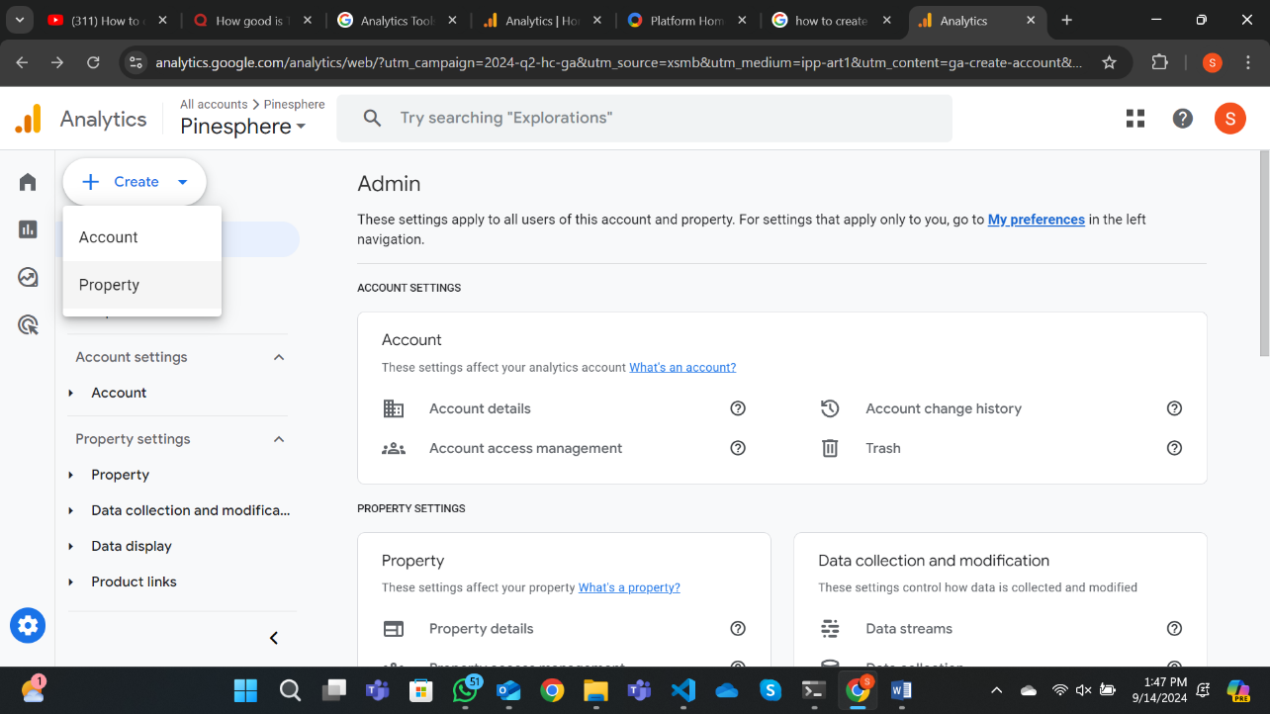

Enter the following property details:

**Name**: The name of the property

**Reporting time zone**: The time zone for reporting

**Currency**: The currency for reporting

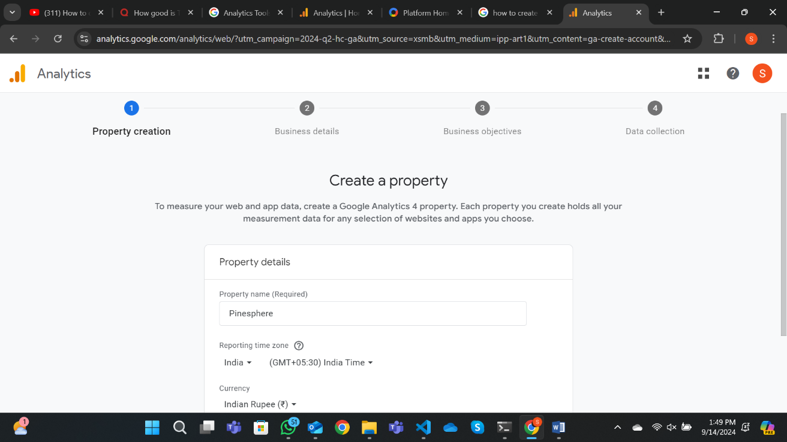

Click Next and fill out the business information.

**Industry category**: The industry category for the property

**Business size**: The size of the business

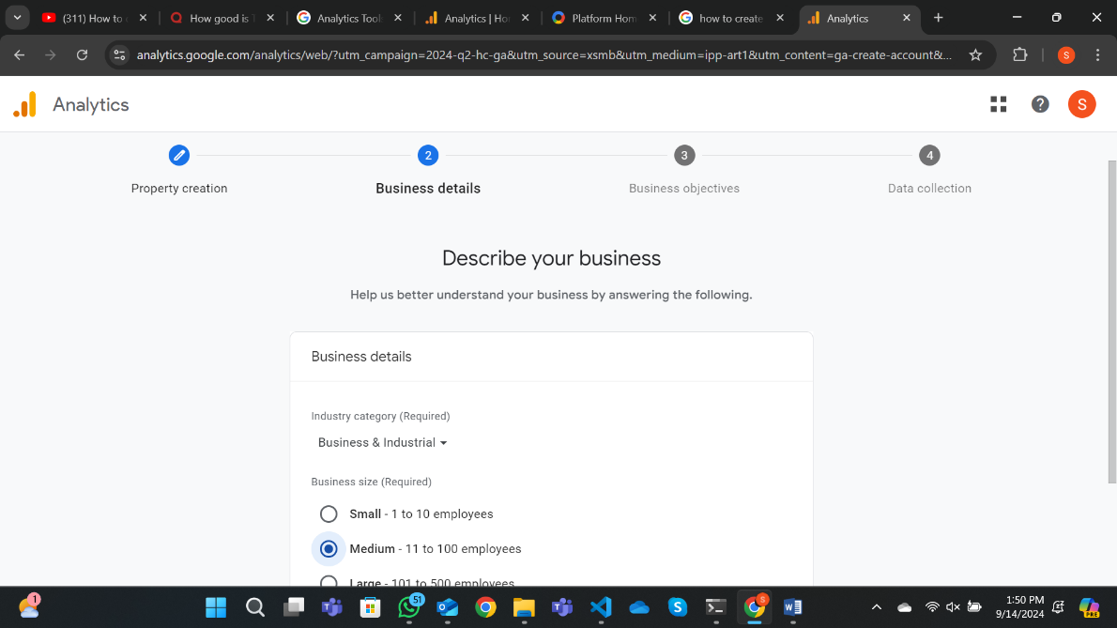

**Business objectives**: The business objectives for the property

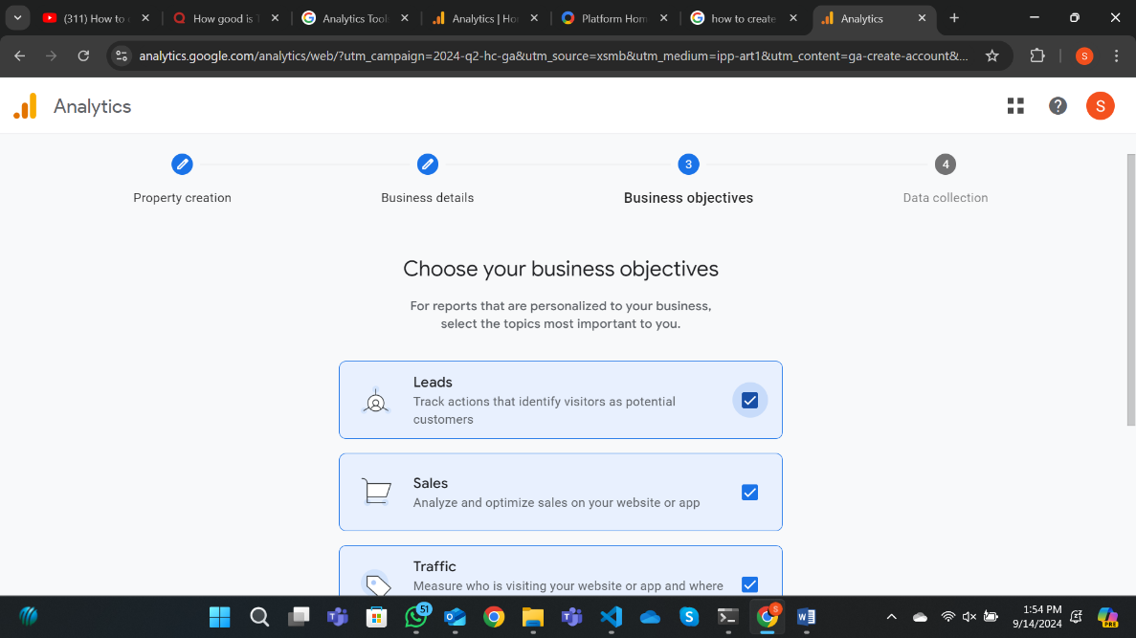

Click **Create** to complete the setup.

Set up from where the data has to be collected

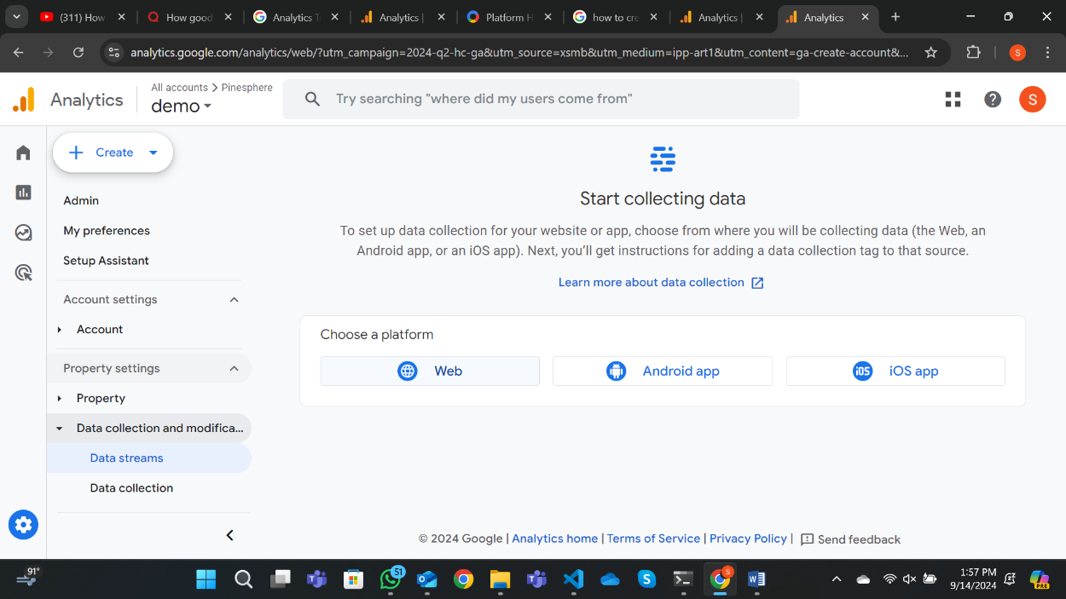

Fill in the website URL and stream name

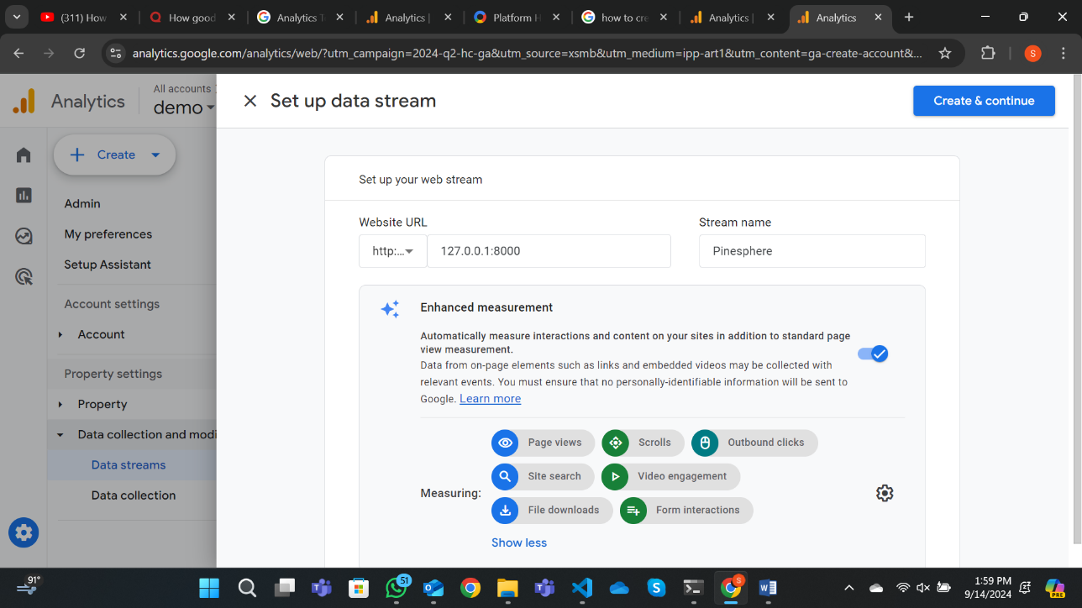

Step 2: Get Your Tracking ID

Once your property is set up the tracking code can be obtained by following steps

Follow the link of the newly created stream and select the “**View Tag Instructions**” option.

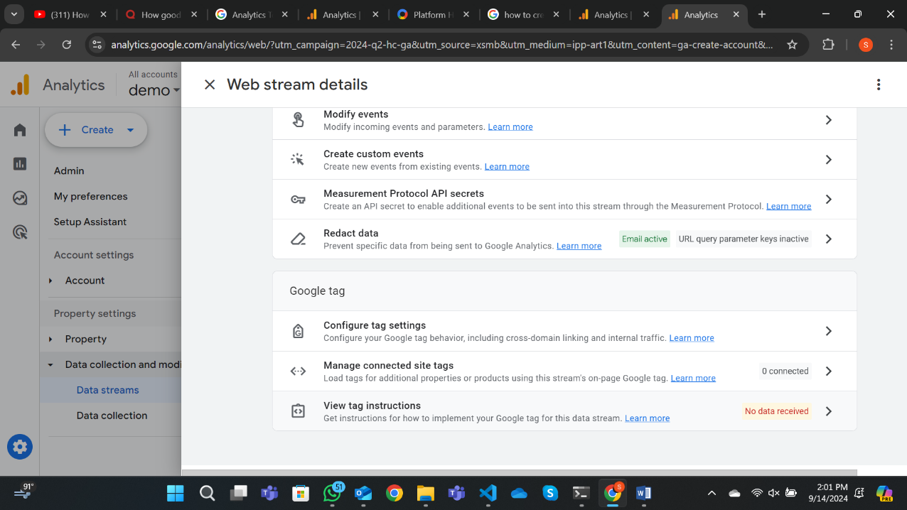

Copy the Google Analytics Tracking Code

To integrate Google Analytics with your Django project, you need to add the tracking code to your template file.

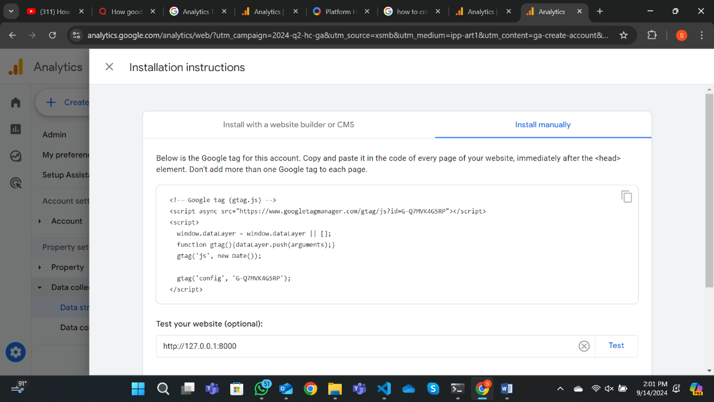

Step 3: Add the Tracking Code to Your Templates

In your base template (e.g., base.html), you need to place the Google Analytics tracking code inside the <head> tag to ensure it is loaded on every page of your site.

HTML:

<!DOCTYPE html>

<html lang="en">

<head>

<meta charset="UTF-8">

<title>Your Website Title</title>

**<!-- Google Analytics Tracking Code -->**

<script async src="https://www.googletagmanager.com/gtag/js?id=YOUR_TRACKING_ID">

</script>

<script>

window.dataLayer = window.dataLayer || [];

function gtag(){dataLayer.push(arguments);}

gtag('js', new Date()); gtag('config', 'YOUR_TRACKING_ID');

</script>

</head>

<body>

{% block content %}

{% endblock content %}

</body>

</html>

Step 5: Include Google Analytics in Specific Pages

In any specific template (e.g., index.html), extend the base template and add your page-specific content.

Google Analytics will automatically be included.

# Integrating Django with Microsoft Clarity

Introduction to Microsoft Clarity

Microsoft Clarity is a free analytics tool designed to provide insights into user interactions with your website. It offers features like heatmaps, session recordings, and engagement metrics, enabling us to understand how users interact with our web application. By integrating Microsoft Clarity with our Django project, we can gain deeper insights into user behavior, improve user experience, and optimize our website for better performance.

Key Features and Uses of Microsoft Clarity

**Heatmaps** – Visualize where users click, scroll, and interact most on your web pages.

**Session Recordings** – Watch user sessions to see exactly how they navigate your site.

**Engagement Metrics** – Track key metrics like bounce rates, time spent on the site, and user interactions.

**Data Filtering** – Filter data based on device, browser, country, and more for detailed analysis.

**Traffic Insights** – Understand the sources of traffic and how users arrive at your site.

Procedure for Integrating Microsoft Clarity with a Django Project

1. Create a Microsoft Clarity Account and create a new project

* Visit [Microsoft Clarity](https://clarity.microsoft.com/projects) and sign up using your Microsoft or preferred account.
* Create a new project for your Django website by entering the name and URL of your website.

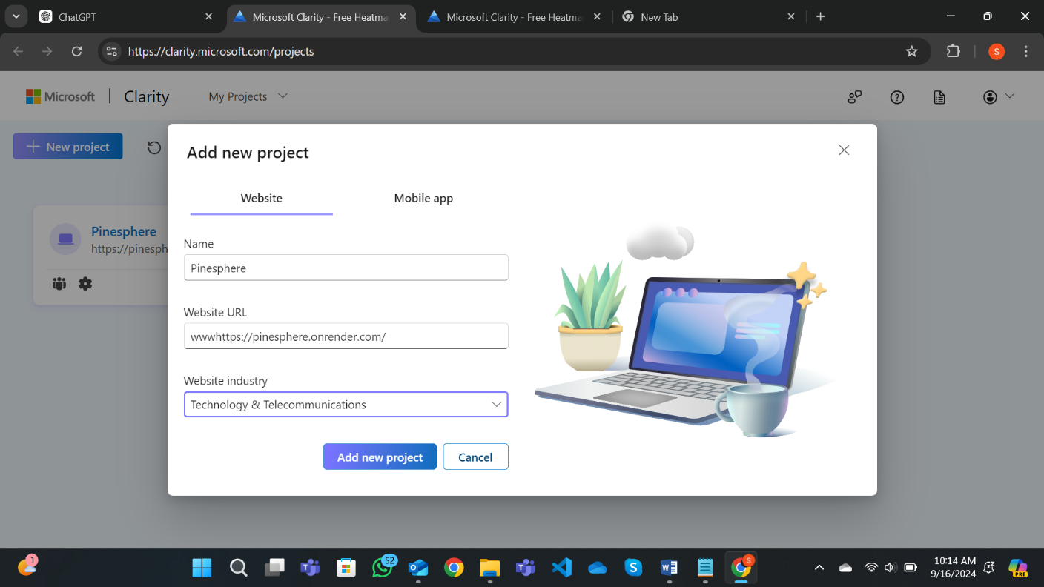

1. Choose an Integration Method

After creating your project, you will be presented with two options to integrate Clarity:

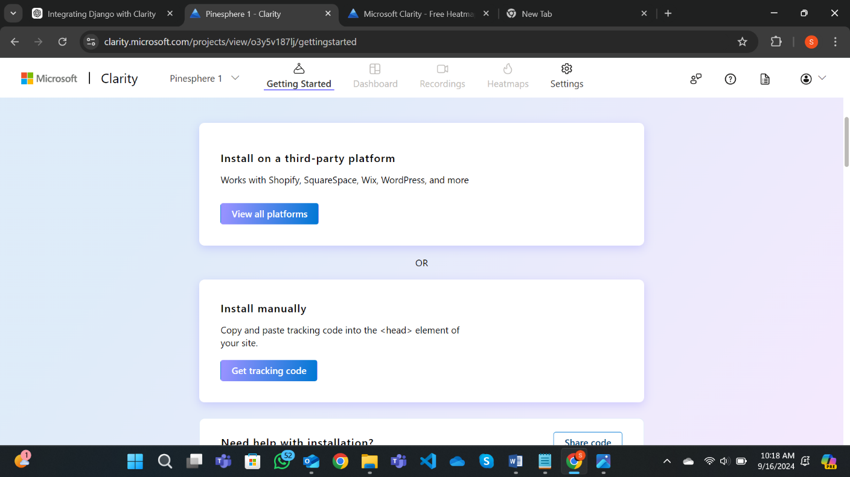

**Option 1**: Install on a Third-Party Platform

* This option allows for quick integration with platforms like Shopify, Wix, WordPress, SquareSpace, and other similar website builders.
* If you're using one of these platforms, select the corresponding option and follow Clarity's platform-specific instructions for integration.

**Option 2**: Install Manually (For Django and Custom Websites)

* Choose this option if you are working on a custom-built website, such as Django project.
* Clarity will provide a JavaScript tracking code that you need to manually add to theDjango site.

1. Obtain the Tracking Code

* By clicking on the option install manually the tracking code is obtained.
* Copy the entire script provided, as you will need to insert it into your Django project.

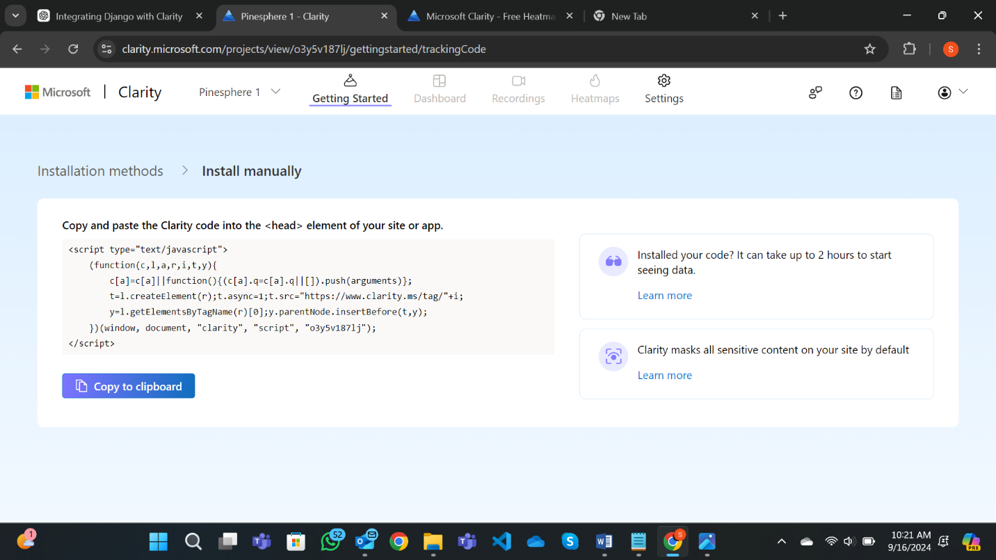

1. Add Clarity Code to Your Django Project

* Navigate to the base template of your Django project (typically base.html or layout.html).
* Paste the Clarity tracking code into the <head> section of your base template, ensuring it appears on all pages:

**html**

<head>

<!-- Microsoft Clarity -->

<script type="text/javascript">

(function(c,l,a,r,i,t,y){

c[a]=c[a]||function(){(c[a].q=c[a].q||[]).push(arguments)};

t=l.createElement(r);t.async=1;t.src="https://www.clarity.ms/tag/"+i;

y=l.getElementsByTagName(r)[0];y.parentNode.insertBefore(t,y);

})(window, document, "clarity", "script", "YOUR_PROJECT_ID");

</script>

</head>

Replace the placeholder **YOUR_PROJECT_ID** with the actual Clarity project ID from your account.

1. Run or deploy your Django project locally to your production environment.

* Visit your site and interact with it to generate some activity.
* Return to your Microsoft Clarity dashboard and check for live tracking or session recordings to ensure proper integration.
* **Note:** It might take some time (typically a few hours) for Clarity to process and display the first set of data.

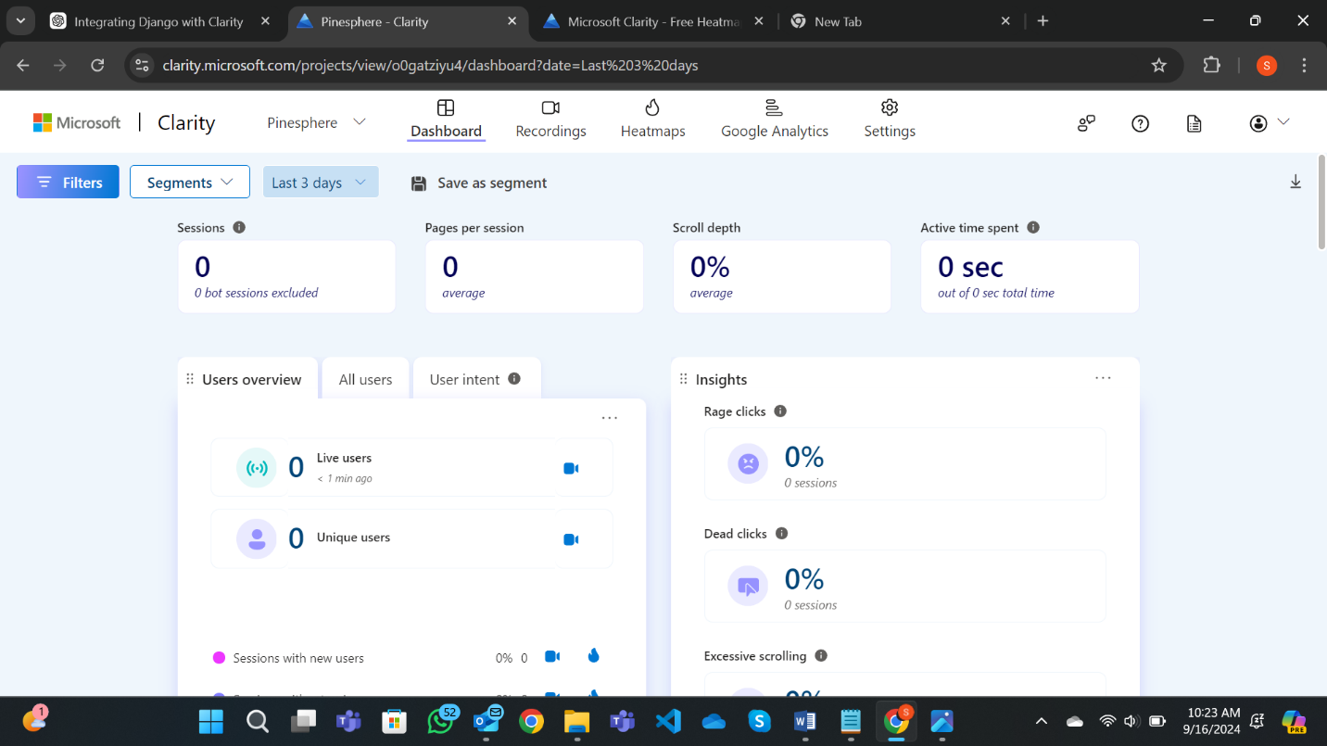

1. Monitor User Data

In the Clarity dashboard, you can now view heatmaps, session recordings, and other analytics related to user interactions on your Django site.

**Recordings Tab:**

In the Recordings tab of Microsoft Clarity, you can review detailed session recordings of how users interacted with your website. Based on the image you shared, here’s a quick guide on what you can do:

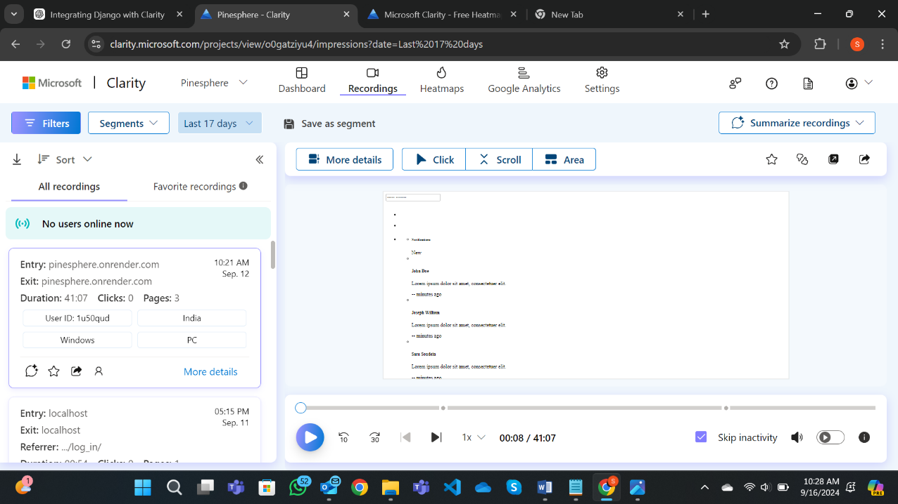

* **View Session Recordings** – The panel shows recordings of user sessions with information such as entry and exit points, duration, clicks, and the number of pages visited. One can play back these recordings to see exactly how users navigated your site.
* **Playback Controls** – Use the playback bar at the bottom to fast forward, rewind, or adjust the speed of the recording. You can also skip inactivity, so you won’t have to watch idle moments in the session.
* **More Details** – Clicking the "More details" button on each session gives you additional insights such as device type, operating system, and geographic location of the user.
* **Favorite or Save Recordings** – Mark important recordings as favorites, or save a segment for future reference and analysis.

This feature is great for understanding user behavior and identifying areas for improving user experience on your website.

**Heatmaps tab:**

Heatmaps tab of Microsoft Clarity, one can visualize user interactions on your website. Here’s how the three main heatmaps work, based on the screenshot you provided:

**Click Map:**

This heatmap displays where users are clicking the most on the website. Areas with more clicks appear brighter or hotter on the map (usually in red or orange), indicating higher engagement.

It helps us understand which buttons, links, or elements are attracting the most user attention.

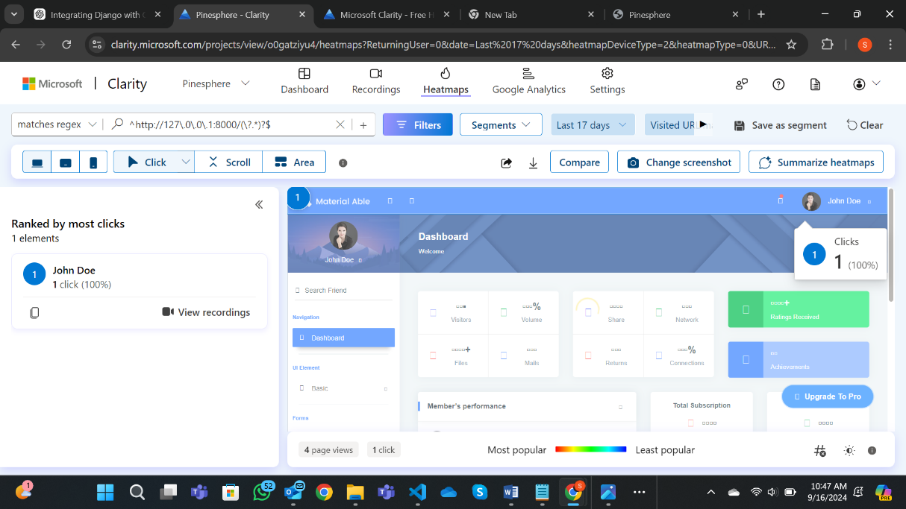

**Scroll Map:**

This heatmap shows how far users are scrolling down the page. The percentage at the top (e.g., "100%") represents how many users viewed that part of the page.

As you move down, the heatmap colors change, helping you visualize where users are dropping off and not scrolling further. It’s useful to identify where to place important content.

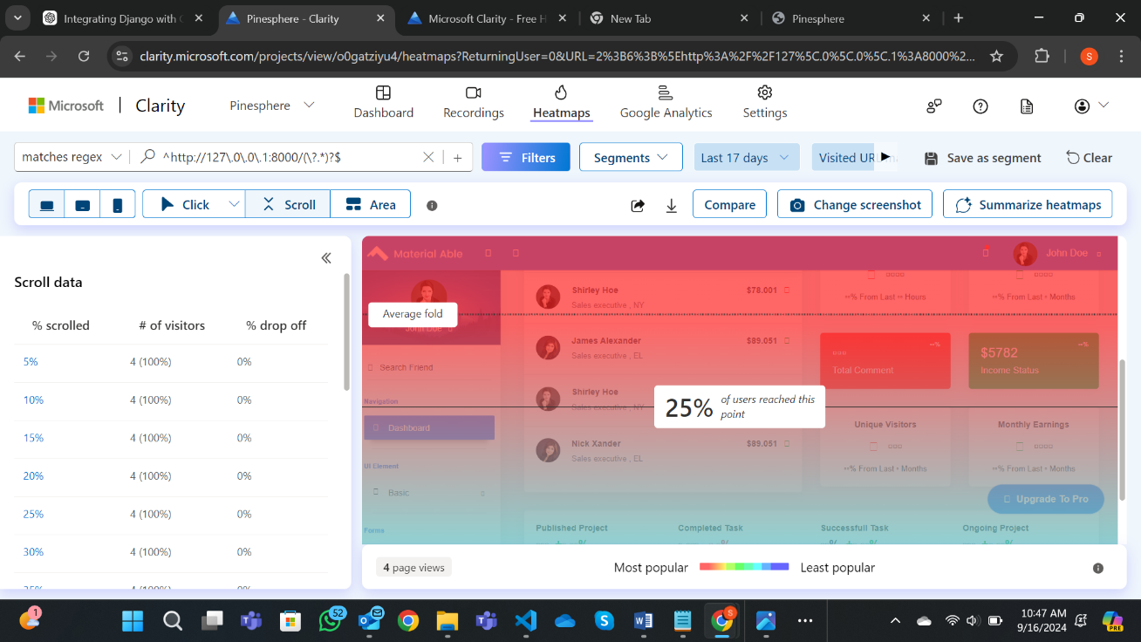

**Area Map:**

This heatmap focuses on specific sections of your site, showing detailed interactions within a selected area. You can choose certain sections of your page (like navigation bars or buttons) to analyze user engagement in these targeted areas.

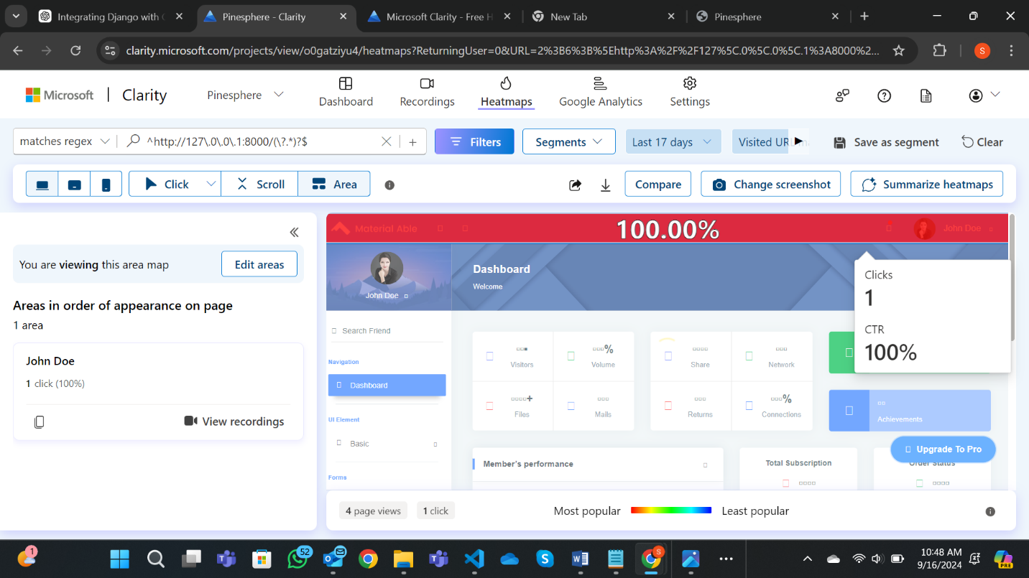

**Summarize Heatmap Button:**

The Summarize heatmaps button allows you to aggregate insights from different heatmaps across devices and interaction types.

By clicking this, Clarity generates an overview of how users interact with your site, combining click, scroll, and area maps into an easy-to-digest summary. This helps you get a clearer picture of user behavior without needing to analyze each heatmap individually.

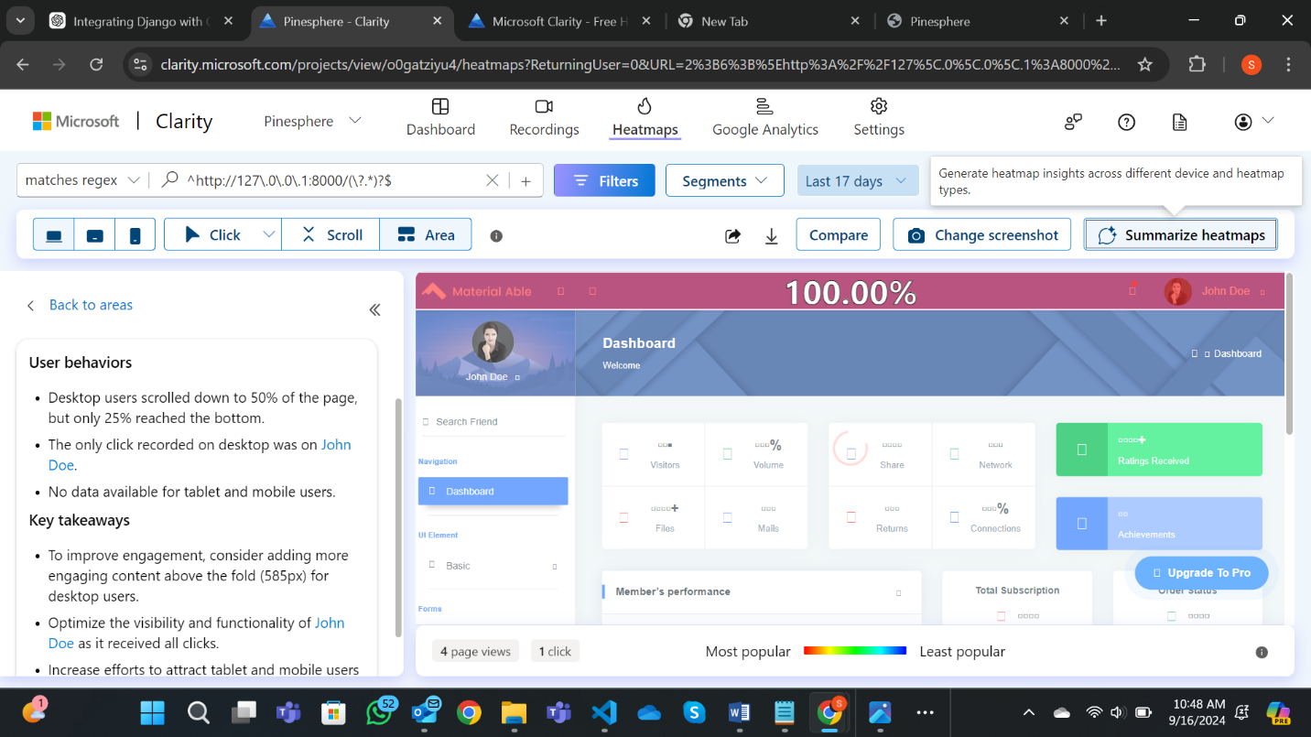

Following these steps, you can easily integrate Microsoft Clarity with your Django project to gain valuable insights into user behavior and improve the overall user experience. Clarity's powerful features provide detailed analytics, allowing for data-driven decisions to enhance your website.

## Search Engine Optimization: SEO stands for “search engine optimization.” In simple terms, SEO means the process of improving your website to increase its visibility in Google, Microsoft Bing, and other search engines. It is the process of making a website more visible and attractive to search engines so that it ranks higher in search results.

## Key Benefits of SEO:

* **Increased Website Traffic**: SEO helps your website rank higher in search engine results, making it easier for people to find your content.
* **Cost-Effective Marketing**: Organic search traffic is free, making SEO a low-cost strategy for attracting visitors compared to paid advertising.
* **Builds Trust and Credibility**: Higher search rankings create a sense of trust and credibility with users, signaling that your site is a reliable source of information.
* **Long-Term Results**: While SEO takes time, its benefits are long-lasting. Once optimized, pages can continue attracting traffic for months or years.
* **Higher Conversion Rates**: SEO targets users who are actively searching for information, services, or products, which often leads to higher engagement and conversion rates.

# Robots.txt:

**Need of robots.txt file**: The most important reason for this is to keep the entire sections of a website private so that no robots can access it. It also helps to prevent search engines from indexing certain files. Moreover, it also specifies the location of the sitemap.

STRUCTURE OF ROBOTS.TXT:

User-agent: {name of user without braces}

Disallow: {site disallowed by the owner, i.e this can't be indexed}

Sitemap: {the sitemap location of the website}

# SEO ON PAGE OPTIMIZATION AND INTEGRATION WITH GOOGLE SEARCH CONSOLE:

1. Create robots.txt file under Templates directory.

**robots.txt** A robots.txt file tells Google which URLs it can crawl, and hence display in its search results.

**sitemap.xml** A sitemap.xml file is used to make crawling more efficient. By creating a sitemap you are telling Google which pages on your website you think are important and providing information on them.

1. Include user agent, disallowed urls and sitemap link  
   User agent : * 🡪 The asterisk (*) is a wildcard character. It means that the rule applies to all web crawlers  
     
   Disallow : -> Allow web crawlers to crawl in all the pages

Sitemap: <http://localhost:8000/sitemap.xml> ---> Provide the link for sitemap

**Code:**

User-agent: *

Disallow:

Sitemap: http://localhost:8000/sitemap.xml

1. Add path in urls.py   
   path('robots.txt', TemplateView.as_view(template_name="pinesphere/robots.txt", content_type="text/plain")),  
   add the path for robots.txt in the urls.py
2. Sitemap creation:
   1. add the app to the INSTALLED_APPS array in settings.py:

INSTALLED_APPS = [

...

'django.contrib.sitemaps'

]

* 1. Create sitemap.py file under your project directory
  2. Django allows dynamic sitemap url creation

**Code:**

from django.contrib.sitemaps import Sitemap

from .models import PineNews

from django.urls import reverse

class PineNewsSitemap(Sitemap):

    changefreq = "monthly"

    priority = 0.6

    def items(self):

        return PineNews.objects.all()

    def location(self, obj):

        return obj.get_absolute_url()

    def lastmod(self, obj):

        return obj.created_at

For every model, the sitemap should be created separately

* 1. changefreq and priority are sitemap-specific properties that define how often each blog post URL will change and how prioritised it is in terms of importance within the overall site
  2. Submit Your Sitemap Manually via Google Search Console:
     + Log in to [Google Search Console.](https://search.google.com/search-console/welcome?utm_source=about-page)
     + Enter the URL of your sitemap (e.g., https://yourwebsite.com/sitemap.xml) and submit it.
     + It will provide a file to add in our project. The file google2ad313d593aff050.html is a verification file used by Google to confirm that you own the domain of the website you are trying to verify in the Google Search Console. Place this file under your static file directory  
         
       <http://localhost:8000/assets/google2ad313d593aff050.html>  
         
       Verify the placement of the file by hitting the above URL.  
       Once the verification is completed you can track your website performance in the property you created under the google search console   
         
       5. Register the sitemap in google search console:
     + Register the sitemap of your website in google search console:

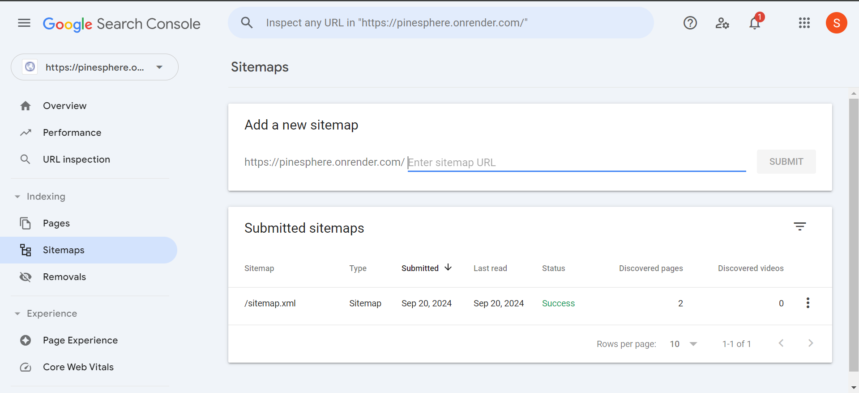

* It might take a day or so to index the pages in the website so that It can display as a result in google search results.

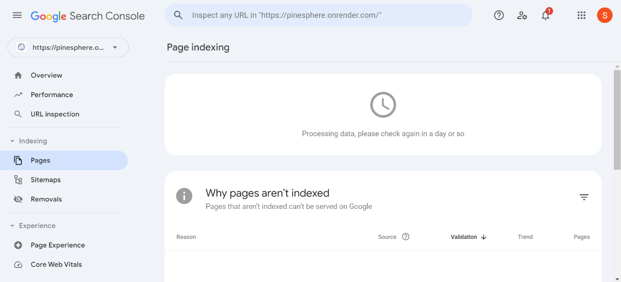

# 

# IMPORTING DATA FROM GOOGLE SEARCH CONSOLE TO BING WEBMASTER TOOL:

**Introduction**

Bing Webmaster Tools is a powerful platform that allows website owners to manage their presence on the Bing search engine. It offers various features to monitor website performance, submit sitemaps, and analyze site traffic. Importing data from Google Search Console can streamline your transition to Bing, allowing you to carry over valuable insights and optimizations that you've already gathered.

**Steps for Importing Data from Google Search Console to Bing Webmaster Tools**

**Step 1:** Sign in to [Bing Webmaster Tools](https://www.bing.com/webmasters/)

* Go to the Bing Webmaster Tools website.
* Click on Sign In in the upper right corner.
* Log in using your Microsoft account credentials. If you do not have an account, you will need to create one.

**Step 2**: Link the bing webmaster tool with google search console

* Once login is verified, navigate to the Site Dashboard of your website in Bing Webmaster Tools.
* Look for the Settings option on the left-hand menu.
* Under Settings, find and click on Import from Google Search Console.

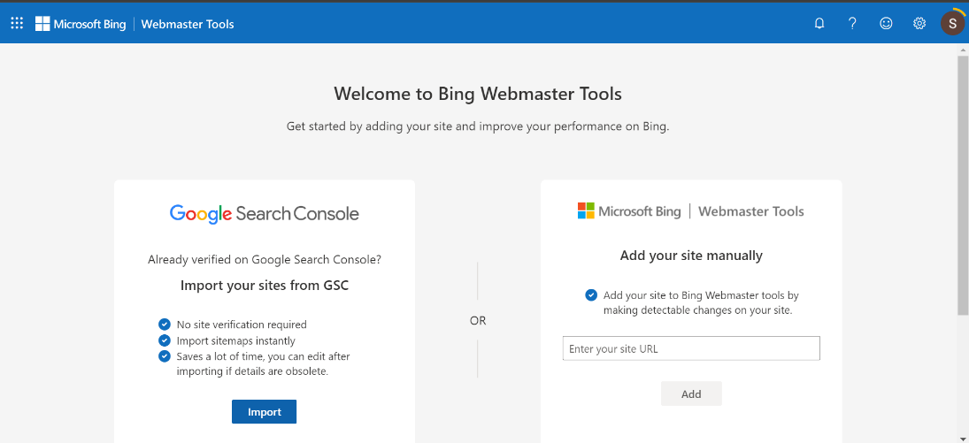

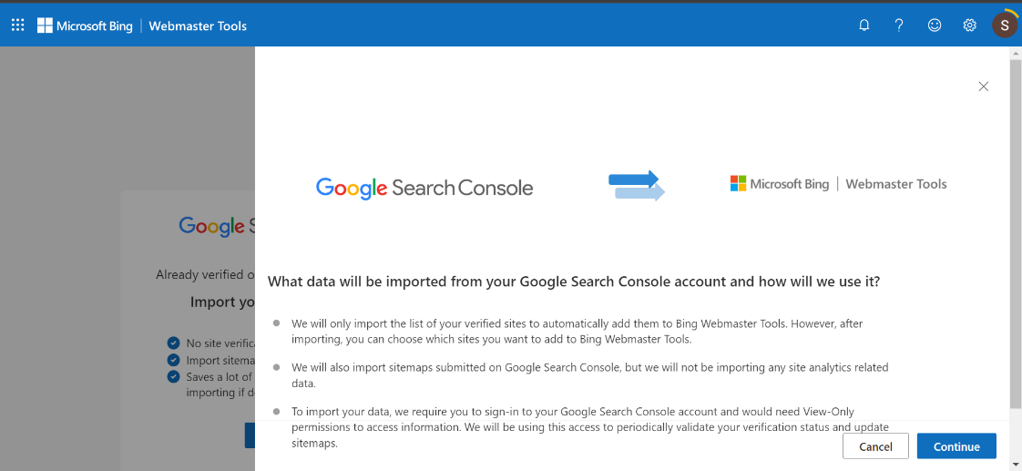

**Step 3:** Connect Your Google Account

* Click on the Import from Google button.
* You will be prompted to sign in to your Google account that has access to Google Search Console.
* Grant Bing permission to access your Google Search Console data by clicking Allow.

**Step 4**: Select Properties to Import

* After connecting your Google account, you will see a list of properties (websites) associated with your Google Search Console account.
* Select the properties you want to import data from by checking the boxes next to them.
* Click Import to start the import process.

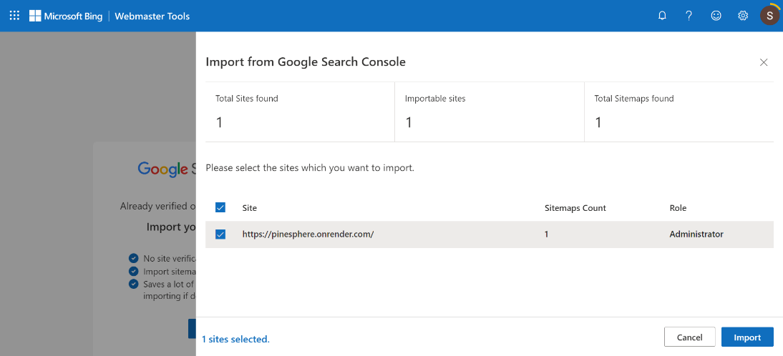

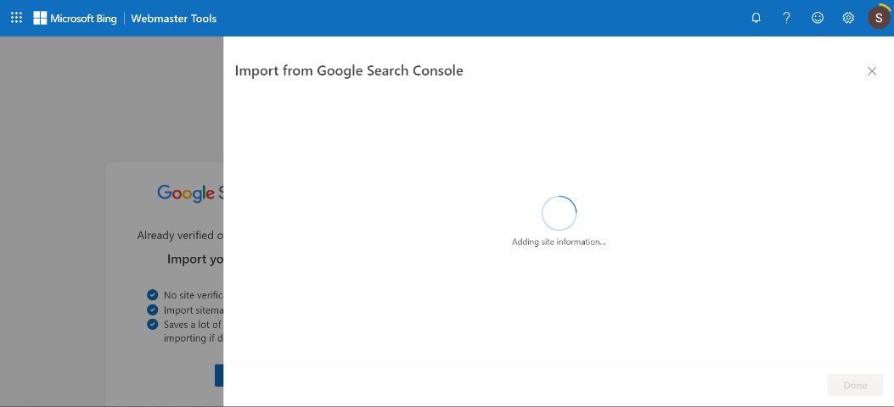

**Step 5:** Review Imported Data

* Once the import is complete, you will receive a confirmation message indicating the success of the operation.
* Navigate back to the Site Dashboard to review the imported data.

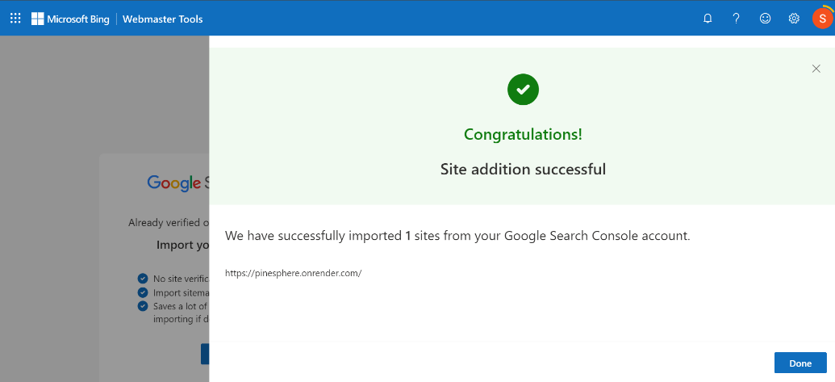

**Step 6:** Monitor Your Site Performance

* Use the various tools and reports available in Bing Webmaster Tools to monitor your site’s performance over time.
* Regularly check for crawl errors, traffic trends, and optimization suggestions to enhance your site's visibility on Bing.
* For initial data import it might take up to 2 days.

